**Friday 26th February**

**LO: To create complex sentences with adverb starters and noun phrases**

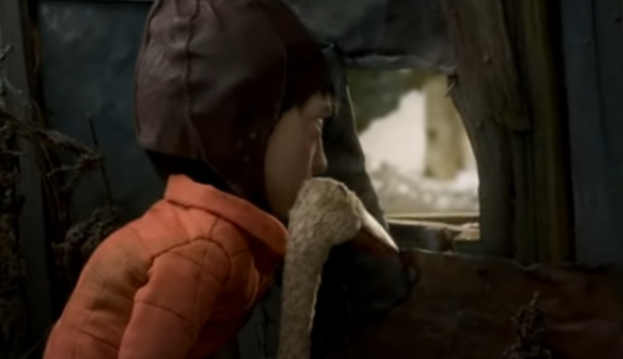My sentences are **awful**! Please add a fronted adverbial, and some detail to the nouns to give the readers a clearer picture in their minds.

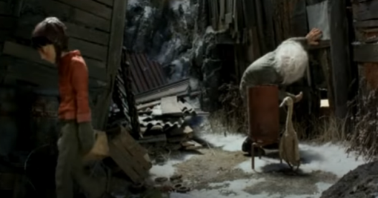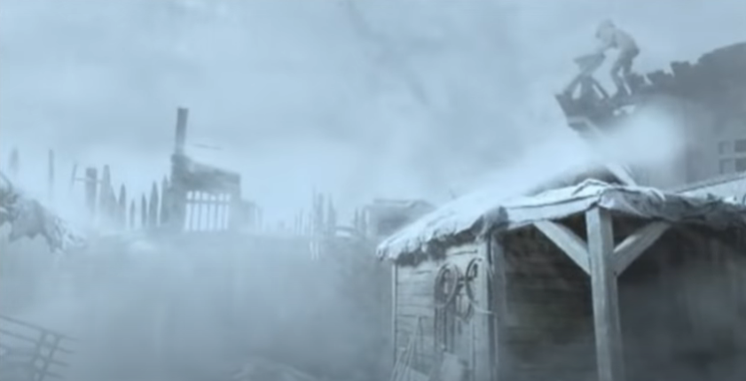

Peter walked off.

____________________________________________________________________________________________________________________________________

Peter and the duck looked through the hole.

____________________________________________________________________________________________________________________________________

The wind blew.

____________________________________________________________________________________________________________________________________

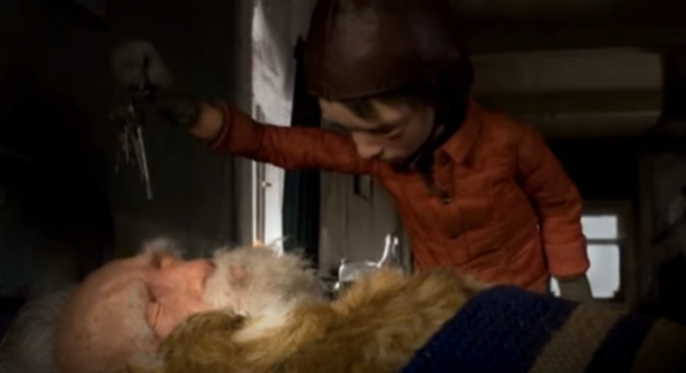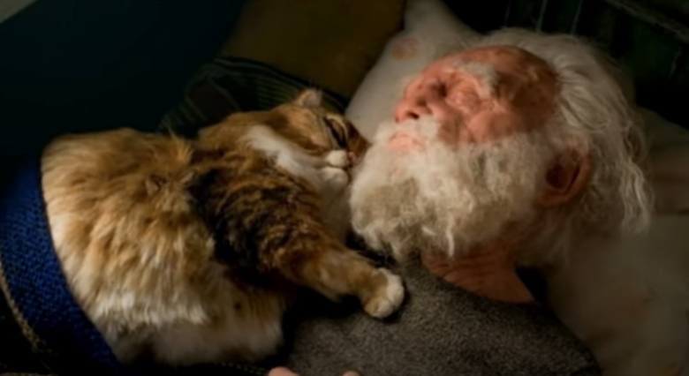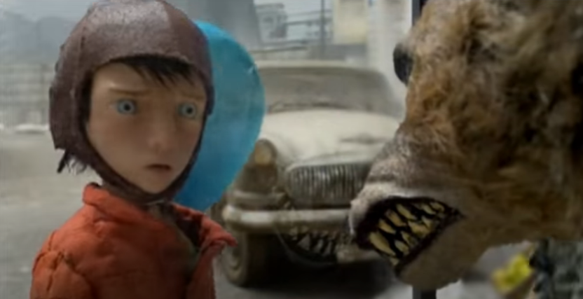

Peter got the keys.

____________________________________________________________________________________________________________________________________

Grandpa slept.

____________________________________________________________________________________________________________________________________

Peter looked at the wolf.

____________________________________________________________________________________________________________________________________