Friday 15th January
LO: To sequence key events in the story
Please give each event a number according to when they happen in the story. Write how Roxanne was feeling at each point in the final column.
Event | Order number | How was Roxanne feeling in this part of the story?
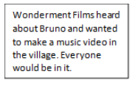

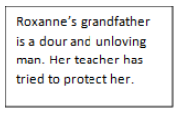

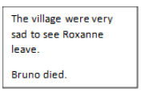

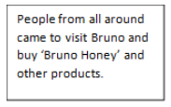

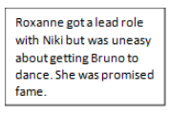

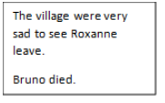

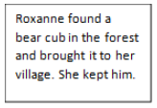
Ideas for feelings vocabulary: mortified, hopeful, excited, content, apprehensive, unloved, unsure, heartbroken, neglected.

