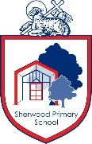

PHONICS

Teach Practise Apply 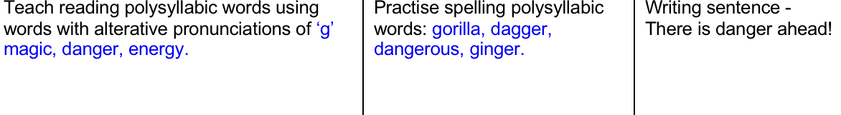

CORE LEARNING TASKS FOR MATHEMATICS

**FOCUS- Multiplication using arrays**

In Year 1, children begin to make arrays by making equal groups and building them in columns and rows to support the beginning of multiplication calculations.

Following on from the exploration work you did on Tuesday, we would like you to complete the following task using arrays.

**Write down as many calculations as you can for 2s, 5s and 10s and draw the corresponding array**. (*Remember – In Year 1, we use repeated addition to write these down)*

For example: 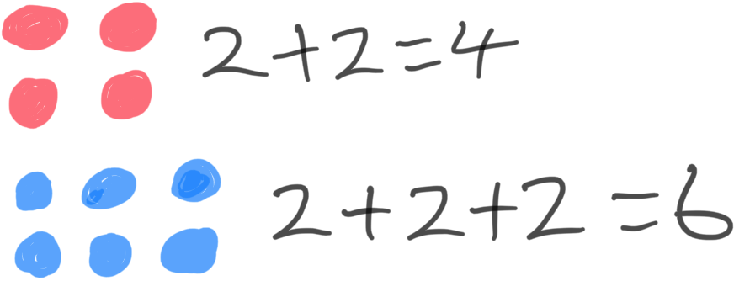

**CHALLENGE**

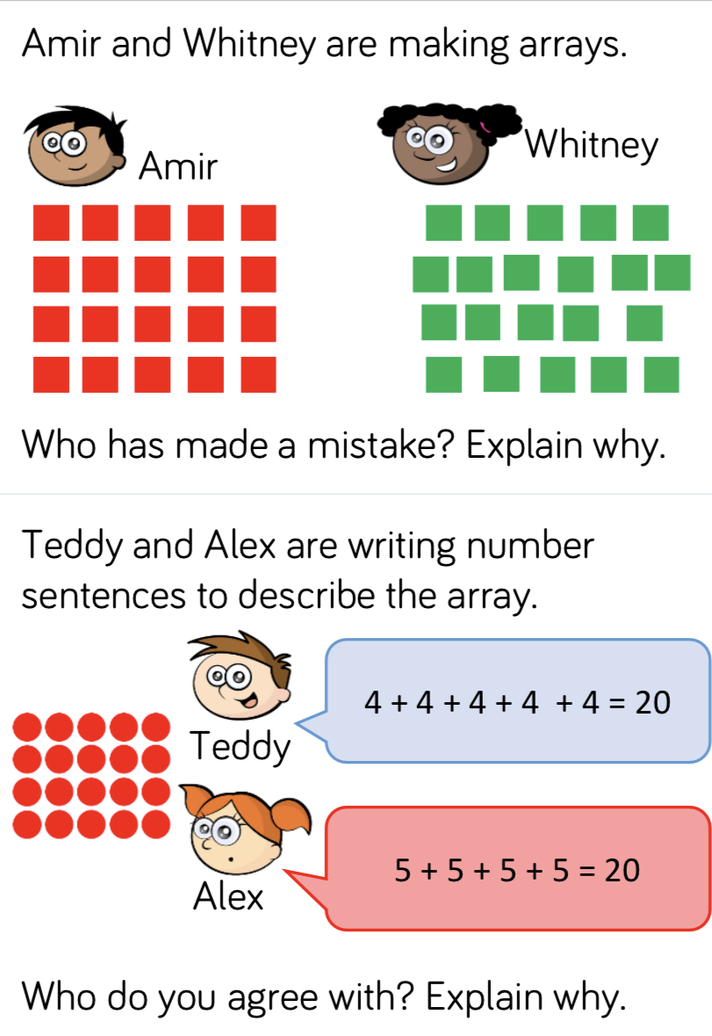 

CORE LEANING TASKS FOR ENGLISH

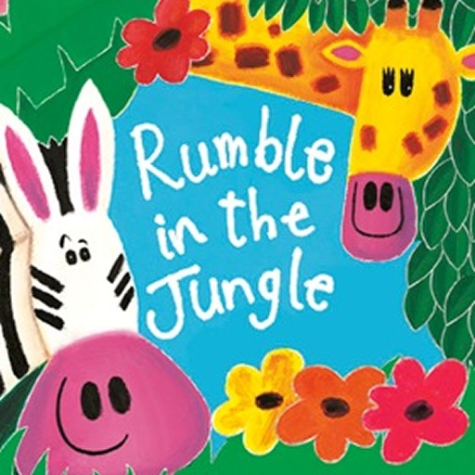

Read again Rumble in the Jungle encouraging your child to join in with the verses if they can.

[https://www.booktrust.org.uk/books-and-reading/have-some- fun/storybooks-and-games/rumble-in-the-jungle/](https://www.booktrust.org.uk/books-and-reading/have-some-%20fun/storybooks-and-games/rumble-in-the-jungle/)

Ask your child to write a short list of animals that live in the jungle that they have heard about in the book. Ask your child to try and spell these animal names independently without peeking at the book, using their phonics knowledge*. (Note: There is no expectation that your child should be able to spell all of these words correctly at this age. They should, however, be encouraged to think about the sounds in the words and ways of spelling each of the sounds)*.

Watch the opening scene of the film ‘The Lion King’

<https://www.youtube.com/watch?v=GibiNy4d4gc>

Watch again but this time pause to discuss and add to the list of animals which live in the jungle. Talk about animals they perhaps have not seen before. Encourage independent spelling again using their phonic knowledge and clapping of the syllables of the animal names, e.g. vulture (two claps), zebra (two claps), elephant (three claps) and hyena (three claps). This list could be recorded as a chart by sorting the animals with one clap, two claps and three claps etc.

<https://www.quora.com/What-were-all-the-animals-in-The-Lion-King>

Look up the rest of the animals shown on the website above and and add to the list, you could even draw some of them!

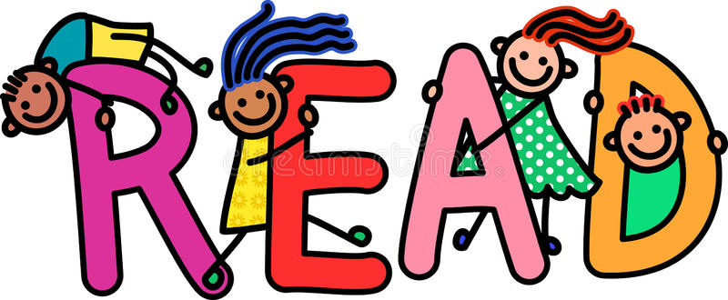

You can now access books online set at Year 1 reading level. Please use the link below to access the login page:

<https://my.risingstars-uk.com/Default.aspx?cid=DL213331>

**Username**: Year1

**Password**: sherwood

**Centre ID**: 213331

KEEPING IN TOUCH

If you have any questions or queries regarding remote learning tasks, please contact your child’s class teacher through the email address below.

We invite you to submit photographs of your children’s experiences and photographs of completed paper based tasks to: [year1@sherwood.lancs.sch.uk](mailto:year1@sherwood.lancs.sch.uk)

SHERWOOD PRIMARY SCHOOL

YEAR 1 REMOTE LEARNING PLAN

Core Learning Tasks for Thursday 21st May 2020