

PHONICS Teach Practise Apply 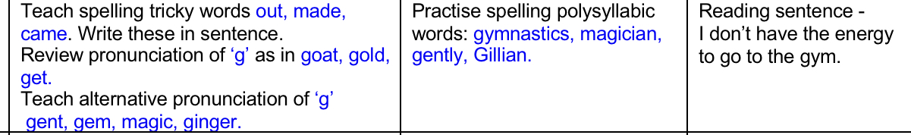

CORE LEARNING TASKS FOR MATHEMATICS

**FOCUS- Multiplication using arrays**

In Year 1, children begin to make arrays by making equal groups and building them in columns and rows to support the beginning of multiplication calculations.

Watch the video below on how to make arrays

<https://youtu.be/XOyOVDMjUdo>

Think about how you use arrays to work out simple multiplication of 2s, 5s and 10s.

Use everyday objects you can find in your house (objects that are the same would be best) to have a play with making different arrays, if you have a baking tray, you could use this as your grid.

Another great tool when exploring arrays is Lego. If you have Lego at home, make some different amounts. You could also just draw the arrays in your book.

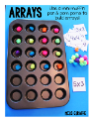 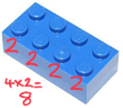 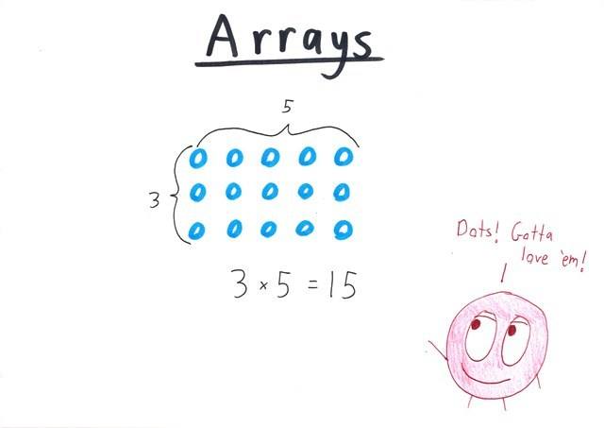

Which ever way, you choose, try to explore lots of different amounts and practice making them practically.

CORE LEANING TASKS FOR ENGLISH

This week, we are going to focus on the book ‘Rumble in the Jungle’. Here is a link to access the book online:

[https://www.booktrust.org.uk/books-and-reading/have-some- fun/storybooks-and- games/rumble-in-the-jungle/](https://www.booktrust.org.uk/books-and-reading/have-some-%20fun/storybooks-and-%20games/rumble-in-the-jungle/)

Read along with your child with the sound on, or mute the sound and read the story/poem out loud to your child. Encourage your child to join in with whichever approach you choose.

Choose your favourite animal and try and re- read that verse either independently or along with the voice over. Ask your child to put actions to some of the words to help them remember, e.g. big (wide open arms).

Ask your child, Why is it your favourite animal in the book? Encourage them to say words or phrases from the text which describe the animal and then complete the prompt orally, e.g. I like the ... because ...

Write a few sentences on their favourite animal from the book. Encourage your child to use words from the text and the word ‘and’, e.g. *I like the gorilla the best because he is big, black and hairy. He is ferocious and scary. He makes me laugh when he wallops his chest.*

Check for capital letters at the start of sentences, full stops at the end, the use of ‘and’ and the capital letter for the word ‘I’.

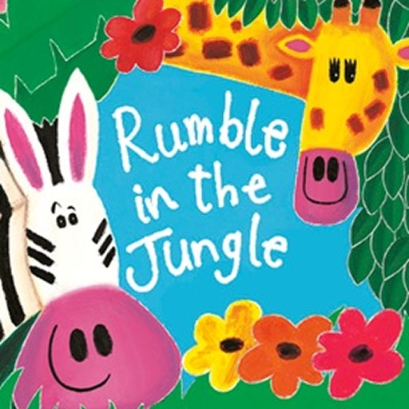



You can now access books online set at Year 1 reading level. Please use the link below to access the login page:

<https://my.risingstars-uk.com/Default.aspx?cid=DL213331>

**Username**: Year1

**Password**: sherwood

**Centre ID**: 213331

KEEPING IN TOUCH

If you have any questions or queries regarding remote learning tasks, please contact your child’s class teacher through the email address below.

We invite you to submit photographs of your children’s experiences and photographs of completed paper based tasks to: [year1@sherwood.lancs.sch.uk](mailto:year1@sherwood.lancs.sch.uk)

SHERWOOD PRIMARY SCHOOL

YEAR 1 REMOTE LEARNING PLAN

Core Learning Tasks for Tuesday 19th May 2020