

SUPERTATO

Mr Wilson will be reading SUPERTATO. Look on the website to see him. We would love you to make your own superhero vegetables!! Send your pictures and we will gather them altogether for a collage after Easter.

SCIENCE BUG HUNT

We would like you to complete a bug hunt in your garden. Please follow the link to help you identify what you can find and even enter a competition when you have completed your hunt.

<http://www.schoolscience.co.uk/bughunt>

NATURAL ART

We would like to complete a piece of artwork inspired by Andy Goldsworthy. You cabin use natural materials but you could also use items things you collect from around the house.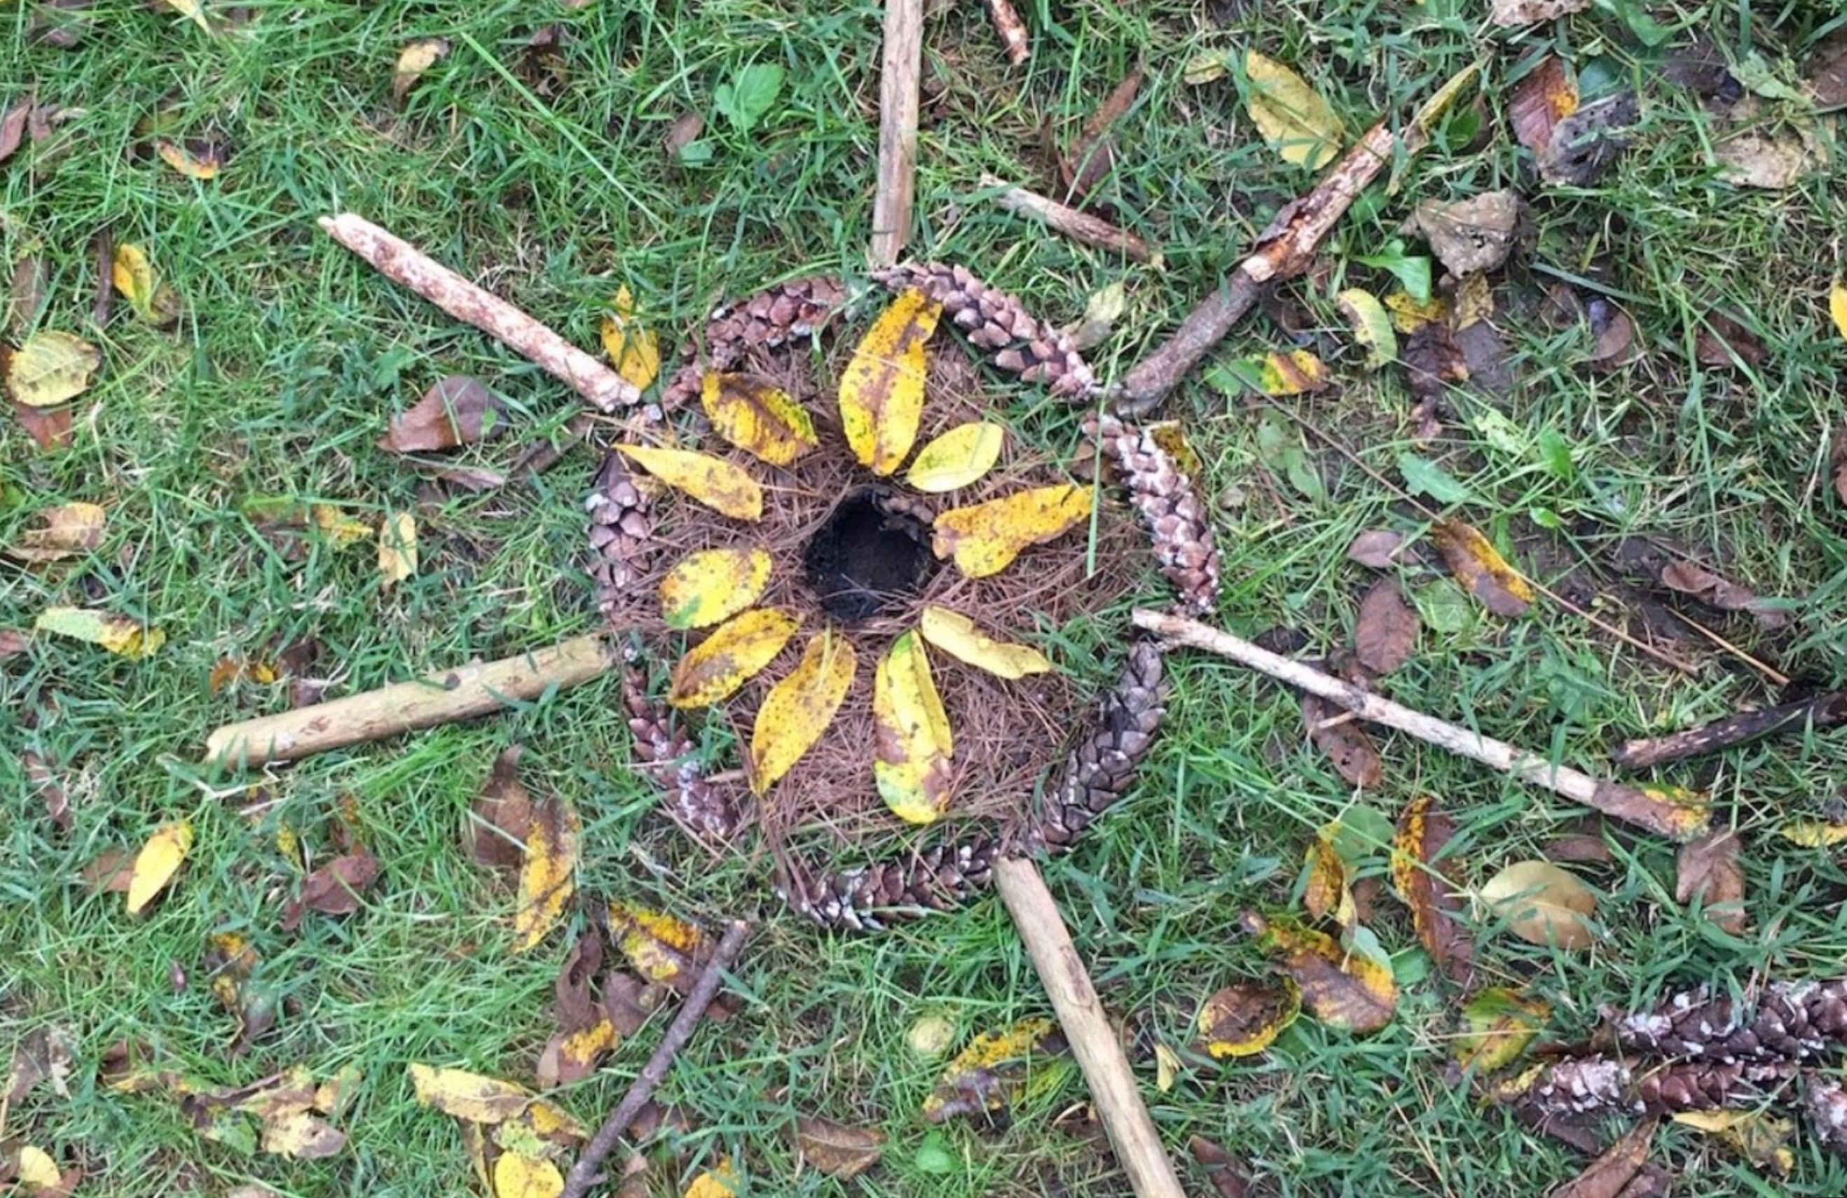

On a long piece of paper with children on each side, create a ‘Garden Picture’ with responding words. E.g. wriggling worms, swaying grasses, zigzag bees etc. Use paint, crayons or any other art materials you have available.

EMAILS

We won’t be responding to emails over the Easter holidays like we have been doing. However, please continue to email us any pictures of the tasks you have been doing or any other fun things you have been up to:

[Year1@sherwood.lancs.sch.uk](mailto:Year1@sherwood.lancs.sch.uk)

The usual remote learning overviews and tasks will be available at the end of the Easter holiday.

OLD TECHNOLOGY HUNT

It’s time to rout through those old cupboards and drawers to find examples of old technology items! Our history topic next half term will be looking at the changes in technology that have occurred over time. We would like you you find different examples you have in your home.

Discuss with your children about what they were used for and what you would use instead today. Can you put them in order from oldest to youngest? Take some pictures and sent them to us then we can use them in our history work.

Happy hunting!!

History Challenge – have a go at completing the time capsule activities. The link will be on the website.

Happy Easter

Happy Easter from all the Year 1 Team!! We all miss you and hope to see you all soon. We hope you are well and looking after each other.

Thank you very much for all your hard work over the last two weeks. It has been brilliant to see lots of children with smiley faces learning at home!! Thank you to parents for sending us the amazing pictures and completing the task with your children at this difficult time!! You’ve all been brilliant!!

Over the Easter holidays, we won’t be setting you tasks like we have been doing over the last 2 weeks. We will give a few ideas to complete on a rainy day. Most importantly we want you to have a break from the laptop and enjoy the time off with each other. Normal service will resume on 20th April 2020.

Thank you once again for all your work and support. Take care.

Happy Easter

The Year 1 Team x

SHERWOOD PRIMARY SCHOOL

Year 1

Easter Activities