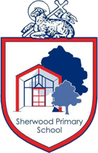

SHERWOOD PRIMARY SCHOOL

YEAR 4 REMOTE LEARNING PLAN

Tuesday 15th November 2021

CORE LEARNING TASK FOR ENGLISH

In our English work today, we are thinking about the whole story of the Pied Piper. What are the key events in the story?

Once you have thought about the plot, watch the video assigned on seesaw where the basic plot will be explained.

Now it is over to you to be creative and begin to plan your own version of the Pied Piper.

I look forward to seeing your plans on seesaw later on today.

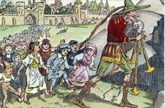

KEY VOCABULARY

perimeter

equal

vertical

horizontal

parallel

chronological

CORE LEARNING TASK FOR MATHEMATICS

In our Maths today, we are continuing to use bar modelling to answer word problems. Remember the key questions to ask yourself when answering a bar model. How many bars do I need? How can I make equal parts?

When you have completed the bar models we are learning how to find the perimeter of different shapes. Please follow these two links and watch my video before completing the activities assigned to you on seesaw.

Perimeter song:

<https://www.youtube.com/watch?v=KwXBMGdSWmI>

<http://toytheater.com/area-perimeter-explorer/>

WIDER CURRICULUM TASK

In history we are learning all about the Great Plague. We would you to create your own timeline of the key events of the plague.

Follow the link on seesaw to watch a video and then organise the images in chronological order.

TIMES TABLES

Remember to keep using TT Rockstars to practise your times tables.